**Shell Scripting**

1. **Description-To read n and generate a below pattern**

1

1 2

1 2 3

1 2 3 4

Input- bash 01_pattern.sh

Enter the value of n:6

Output- The expected pattern is

1

1 2

1 2 3

1 2 3 4

1 2 3 4 5

1 2 3 4 5 6

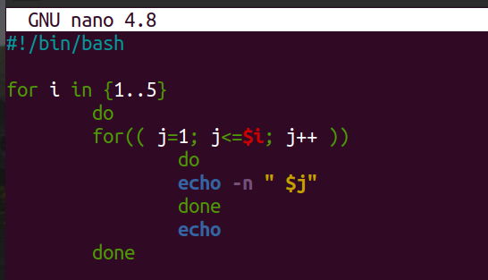

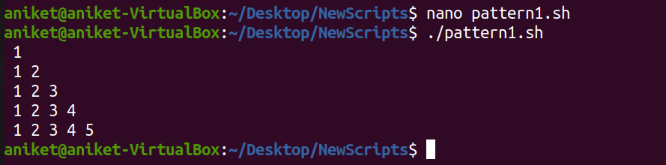

1. **Description-To read n and generate a below pattern**

1

2 3

4 5 6

7 8 9 10

Input- bash 02_pattern.sh

Enter the value of n:4

Output- The expected pattern is

1

2 3

4 5 6

7 8 9 10

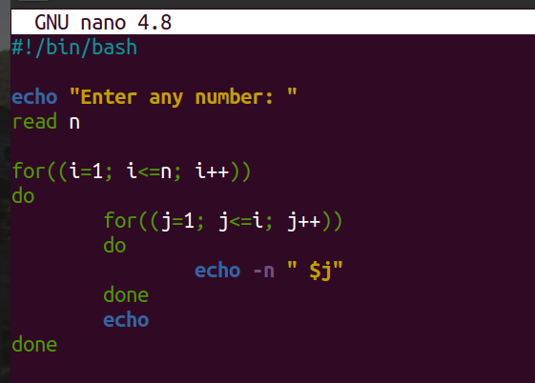

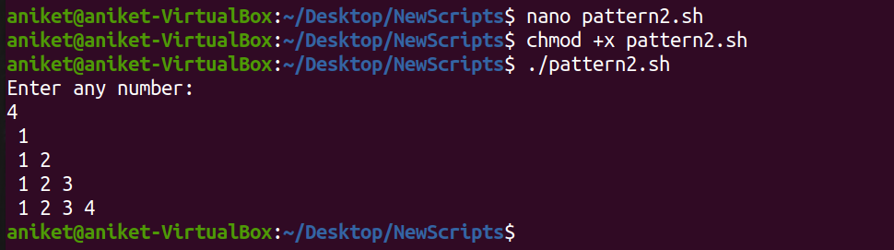

1. **Description-Script for the addition of two real numbers**

Input- bash 03_real_add.sh

Enter the numbers to addition: 4.28 1.21

Output- The sum of 4.28 and 1.21 is 5.49

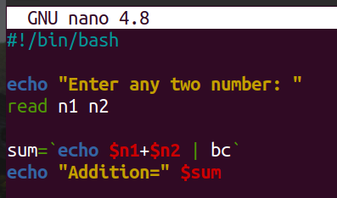

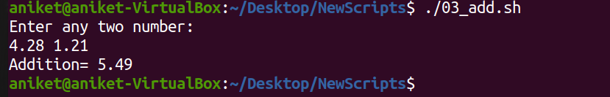

1. Description- Script for an arithmetic calculator using command-line arguments

Input- bash 04_calculator.sh 1.2 + 2.6

Output- The sum of 1.2 and 2.6 is 3.8

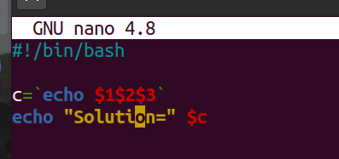



1. **Description- Script to compare larger integer values from an 'n' number of arguments using command line arguments**

Input- bash 05_largest.sh 1 3 8 6 5 7 9 2

Output- The largest value is 9

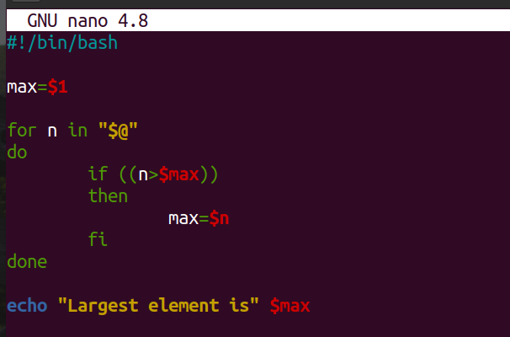

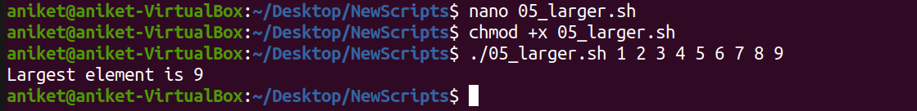

1. **Description- Script to print a given number in reverse order.**

Input- bash 06_reverse.sh 639872

Output- The reversed number of entered number is 278936

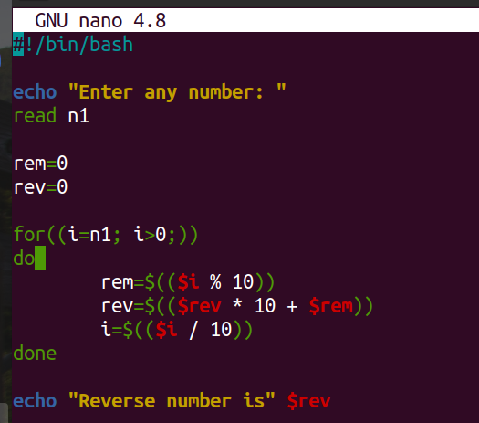

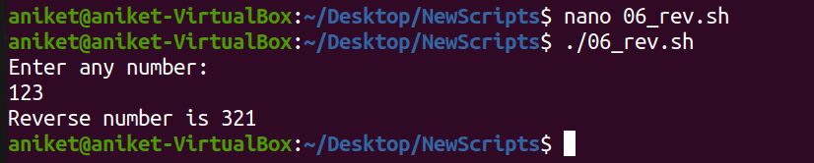

1. **Description- Script to delete empty lines from a file**

Input- bash 07_delete_empty_lines.sh file.txt

Output- All empty lines of the file file.txt will be deleted

Before script running, content of the file file.txt :

Hello, I am Siddaling.

I am from Belgaum.

I studied B-Tech in ECE.

After script running, content of the file file.txt :

Hello, I am Siddaling.

I am from Belgaum.

I studied B-Tech in ECE.

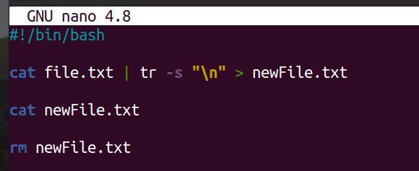

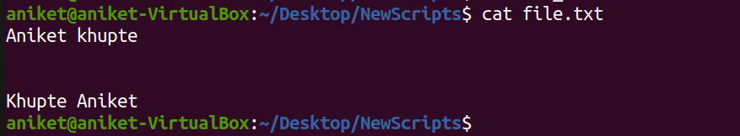

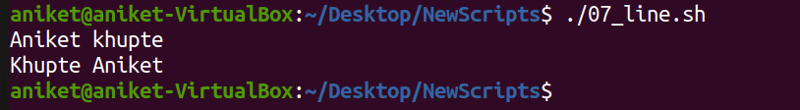

1. **Description- Script to perform an arithmetic operation on digits of a given number depending upon the operator.**

Input- bash 08_operator_dependent.sh 12354+

Output- The sum is 15

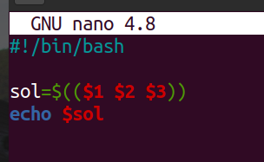

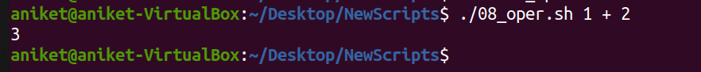

1. **Description- Script to print the length of each and every string using arrays**

Input- bash 10_string_length.sh hello, I am Siddaling

Output- The lengths of each string are as below:

length of the string(hello,) -6

length of the string(I) -1

length of the string(am) -2

length of the string(Siddaling) -9

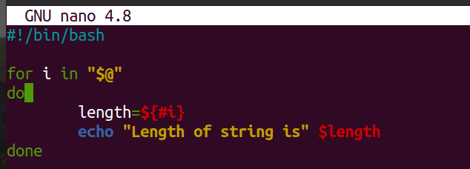

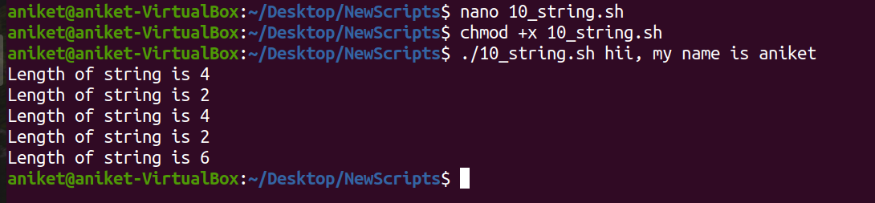

1. Description- Script to sort a given number in ascending or descending order.

Input- bash 12_sorting.sh -a 96 12 85 36 25 1 9 14 14 11

Output- The ascending order of the array is:

1 9 11 12 14 14 25 36 85 96

